LAB 4 – APPLCIATION PROGRAMMING

1. Enter choice 2 to display inventory, without adding items in the inventory  
   +
2. Enter choice 3 to search and display inventory items, without adding any item in the inventory

1. Choose option other than the valid choices (1, 2, 3, or 5). It could be alphabet or numeric value  
   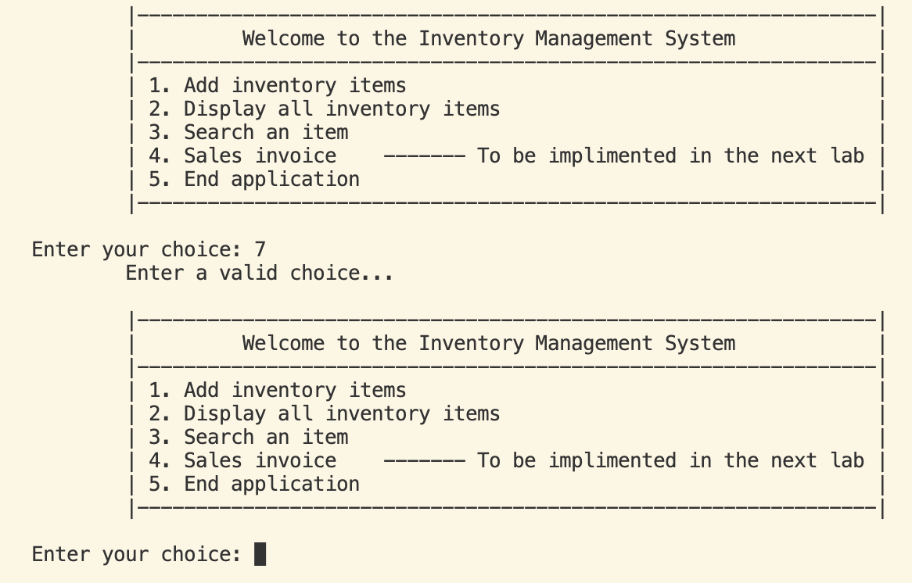
2. Add two to three items in inventory and display using option 2.  
   Table

   Description automatically generated with medium confidence
3. Add an item having identical Serial Code to an existing item in the inventory to show that quantity is updated without updating the item price  
   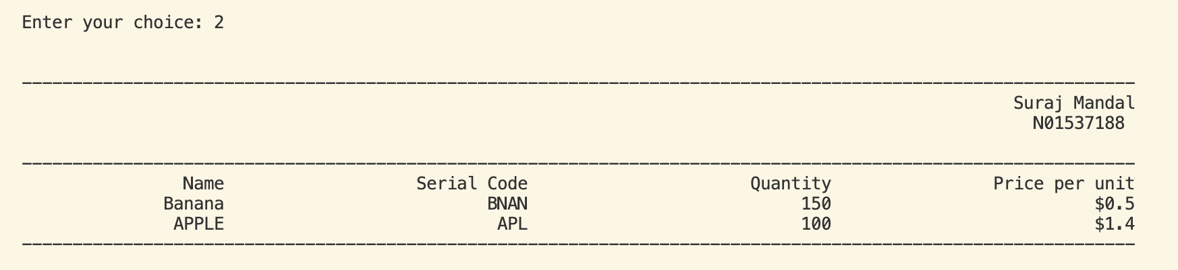  
   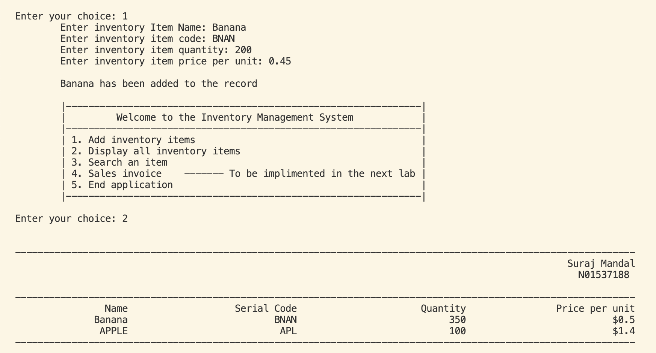  
     
     
     
     
     
     
     
     
     
     
     
     
     
     
   NEXT PAGE
4. Add an item having identical Serial Code to existing item in inventory, but having higher item unit price to show the update in inventory quantity as well as inventory price (unit price)  
   Table

   Description automatically generated
5. Search inventory when Item is in the inventory  
   Table

   Description automatically generated
6. Search inventory when Item is NOT in the inventory.  
   Graphical user interface, text, application, email

   Description automatically generated
7. Enter valid choice as option as well as invalid choice as an option (to show the messages displayed)  
   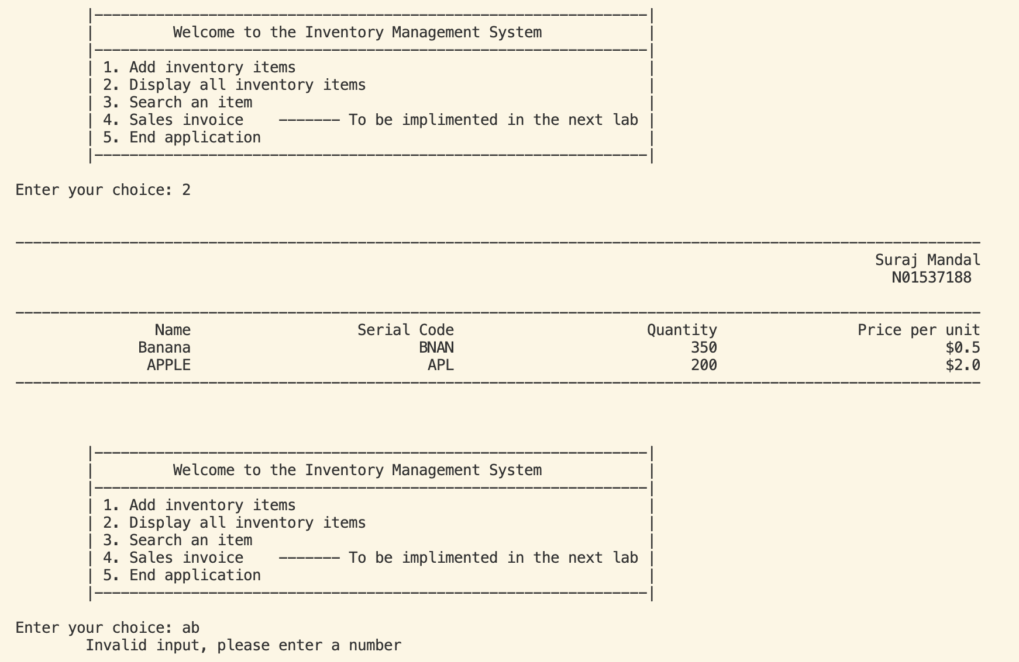
8. Demonstrate how application ends  
   Graphical user interface, text, application, email

   Description automatically generated